Dockerize full stack application (MERN)
Workflow
1. Browser → Nginx
2. Nginx → Backend
3. Backend → MongoDB

🟢 STEP 1 - You open browser
http://localhost – who receive this? Nginx

🟢 STEP 2 - Nginx decides where to send
My config,
- / means frontend
- /api means backend
So,
http://localhost means frontend
http://localhost/api/users means backend
That’s it

🟢 STEP 3 - Backend works
Backend receives: /api/users → /users
- Gets data from MongoDB
- Return JSON

That’s the whole system
Browser
↓
Nginx (brain)
↓
Frontend OR Backend
↓
MongoDB

Nginx Configuration

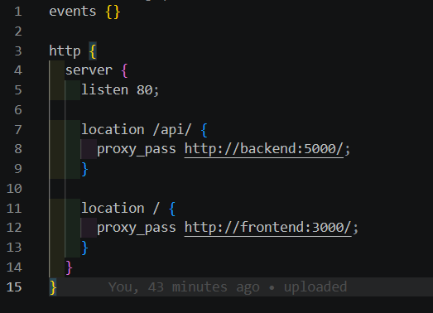
- Line number 7 means: if the URL starts with /api/, do something.
- proxy_pass http://backend:5000/; → Forward these requests to a server called backend on port 5000.
- So if you go to http://yourdomain.com/api/users, Nginx will actually send it to http://backend:5000/api/users.

- Line number 11 means This is a catch-all for everything else (like /home, /about, or /).

- proxy_pass http://frontend:3000/; → Forward these requests to a server called frontend on port 3000.

Docker compose
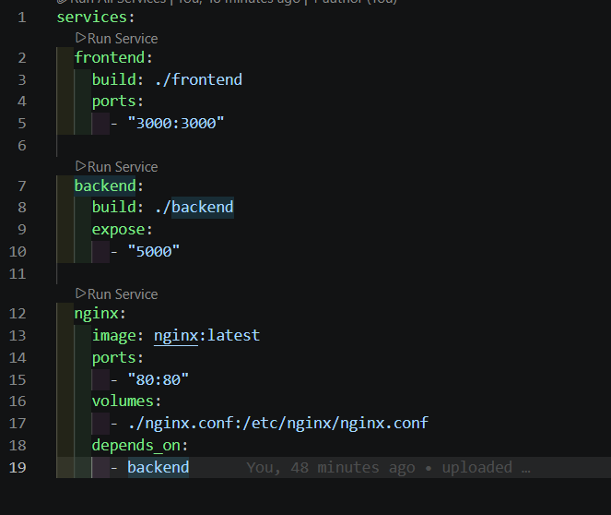

- build: ./frontend → Docker will build an image using the Dockerfile in the frontend folder.
- ports: "3000:3000" → Exposes port 3000 from the container to your host, so you can access it at http://localhost:3000.

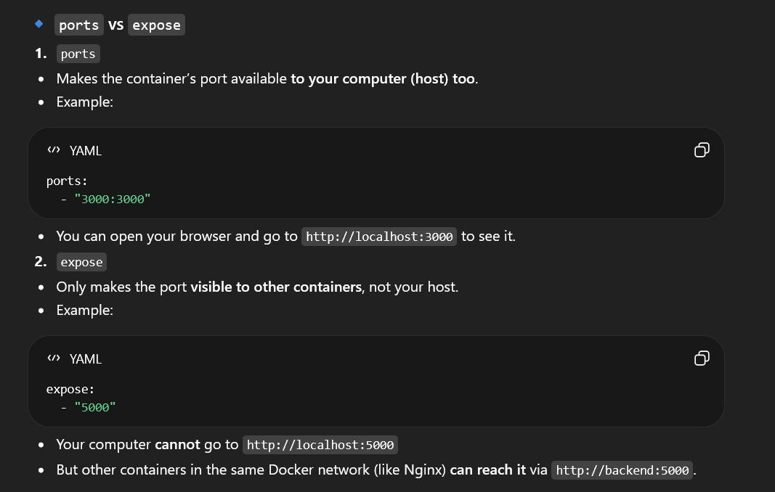

Why use expose for backend?
- You don’t want to open your backend to the outside world.
- Only Nginx should talk to it.
- Nginx sees it as backend:5000 because Docker makes a private network for all your containers

In line 17,
volumes: ./nginx.conf:/etc/nginx/nginx.conf → Uses your custom Nginx config from your project.
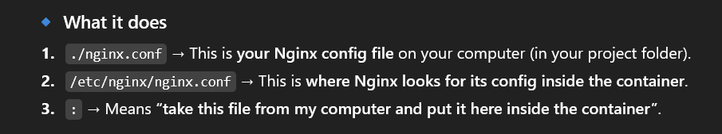

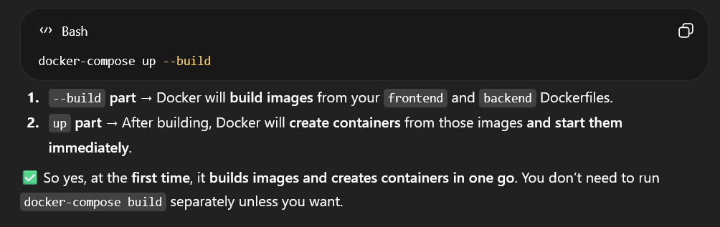

What happened when we do not give specify name for containers and images
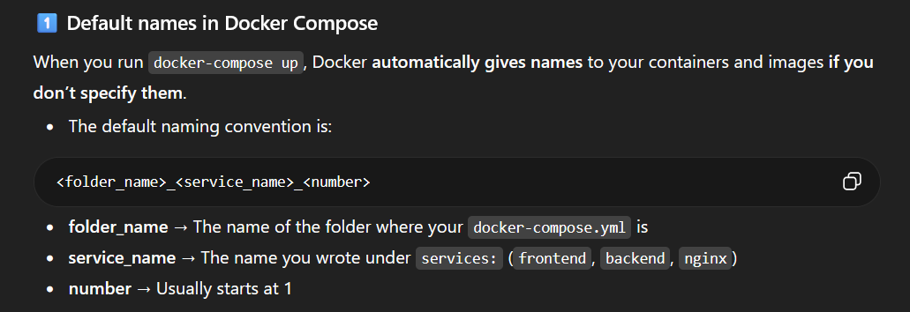

Example names
Mernstack_frontend_1
Mernstack_backend_1
Mernstack_nginx_1
Images use
<folder_name><service_name>

Mern_Stack_frontend
Mern_Stack_backend

Then which time that container number change
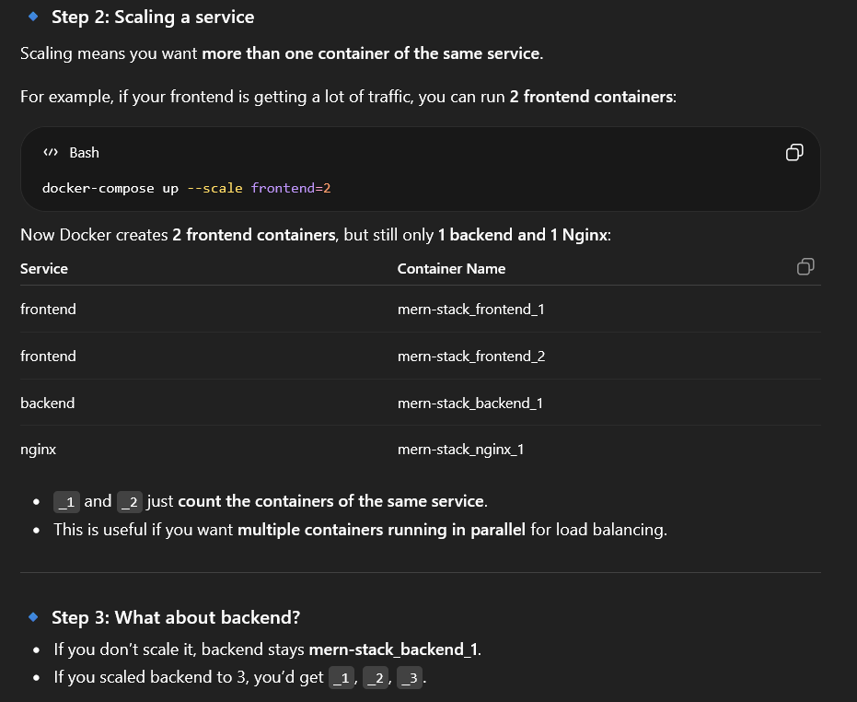

Port Configuration Guide
This project reads the backend port from environment variables.
Install dotenv (for .env support)
- Run this inside the backend folder:
cd backend
npm install dotenv

- Then load env variables at the top of backend/server.js:
Require(“dotenv”).config();

Without dotenv, values from .env (like PORT) will not be available in process.env.

Files to change when you want a new backend port
- backend/.env
- Change PORT values
- Example
PORT=2000

- backend/server.js
- Keep this line
const PORT = process.env.PORT || 5000;
- This means it uses .env first, then falls back to 5000.

- Docker-compose.yml
- Update backend port mapping to match container port used by Node
- Example for port 2000
"2000:2000"

- nginx.conf
- Update backend upstream port inside Docker network
- Example for port 2000:
proxy_pass http://backend:2000/;

Example: change backend from 2000 to 5000

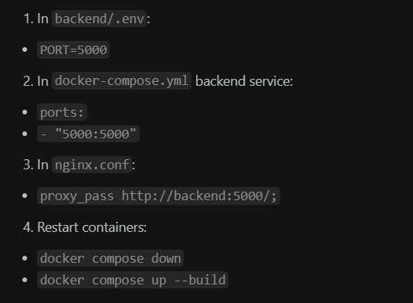

How to test
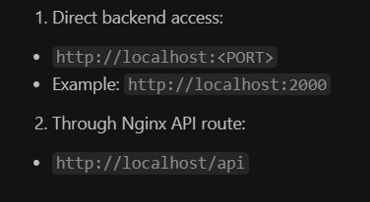

Common issue
If .env says PORT=2000 but Docker/Nginx still use 5000, API calls fail. Always keep these three values aligned:
- backend/.env PORT
- docker-compose.yml backend ports mapping
- nginx.conf backend proxy_pass port

